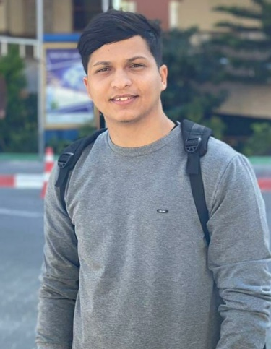

Yasser A . ABU AMRO ABUAMRO

[Yasseramr7715729@gmail.com](mailto:Yasseramr7715729@gmail.com)

Age: 19 years old



+972597715729



Gaza – Mansoura Street





**FORMATIONS**

- 2020/2021: **High School certificate** (86.8%), palestine Secondary School for boys Gaza-Strip

**SKILLS**

* Communication skills and self-confidence
* Work under pressurs and be patient when work pressure increases
* Make timely decisions
* Tact and diplomacy
* Prioritize work

LANGUAGUE

* Arabic: native
* English: medium
* German : medium

SOFTWARES

* Word ++
* Excel +++
* Autocad +++
* Front end (HTML5 , CSS3 , JS , BOOTSRAB) +++

VOLUNTEER

* Reading aid for visually impaired students (High School)
* I volunteerd at Shifa medical hospital researiching the cleandiness of surgical operating rooms

HOBBIES

* Translation and subtitle creator movies & series
* Football
* Reading books
* Horse riding